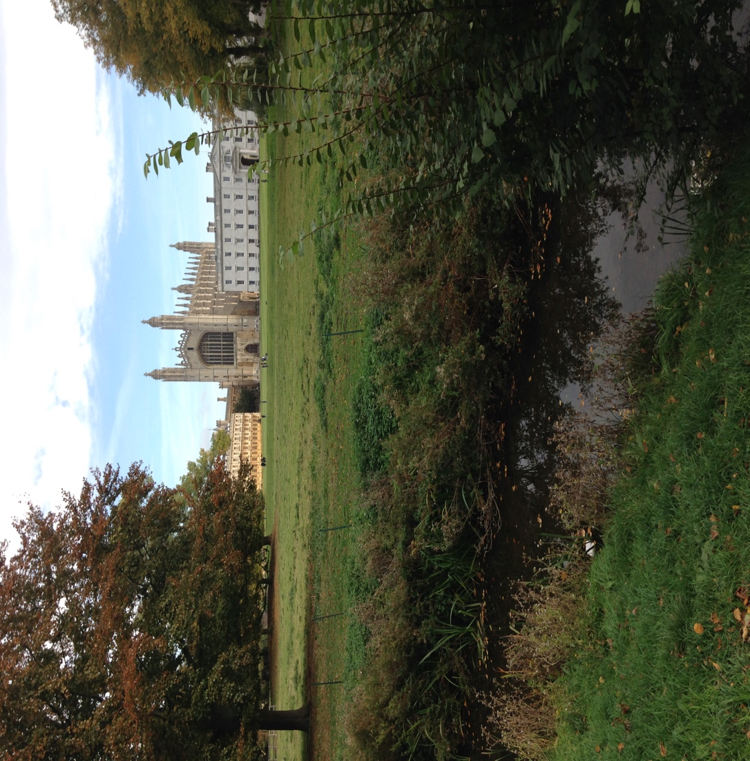

I’ve been thinking a lot about significance lately and would love to start a conversation with you about it. How do you define significance? Who are the people who model significance to you, and how are you consciously (or unconsciously) pursuing significance in your own life? Is it through what you’ve achieved, your children and grandchildren, following your passion, using your gifts and talents to help others? Because we all long for significance in our lives, to know that we matter and what we do has purpose. Like this blog, for instance. I thought words were significant. But in the social media world, it’s all about numbers. Social media has this way of making me feel very insignificant! So, in a world of master bloggers, why blog at all!

Here is how the Oxford Dictionary defines significance:

n. 1. importance; noteworthiness; having a meaning

And I love this:

In math, a significant figure is a digit conveying information…
not a zero used to fill vacant space at the beginning or end.

Can you believe that’s in the dictionary? Yikes! I have to ask myself—Am I a significant figure, or a zero simply filling vacant space? Boy, I sure feel like a zero sometimes. I guess we all have to ask what kind of “information” are we conveying about our lives?

I live in Cambridge, England, and there are a lot of people here, past and present, whose significance has changed the world. Names like Erasmus, Tyndale, Newton, Wilberforce, Darwin, Hawking are just some of the greats associated with this place. Cambridge University has produced Nobel laureates in every category. Writers, musicians, and scientists who defined their century have wandered the same streets and meadows as I do. Kings built architectural wonders here, the most iconic and beautiful being King’s College Chapel overlooking the River Cam. The life changing but invisible structure of DNA was revealed over a lunch break in a favorite pub. You could easily say Cambridge is one of the most significant towns in the world. If you surround yourself with such significance, does it rub off? Meaning, does one’s halo shine a little brighter from standing next to the sun?

I guess it goes back to how you define significance. Genius and significance don’t necessarily go hand in hand. Thank goodness! I may live in this rarefied stratosphere of eight centuries of greatness, but very few of us on this earth are going to be Nobel Prize winners or make fabulous discoveries or create iconic works of art. Our significance exists on a much humbler level, and that is, in spite of the numbers, we are each called to live lives of significance in our own unique way. If you believe, as I do, that we are created in the image of God, then each one of us has value on a tremendous scale. We have not been born as zeros filling up a short bit of space.

So,what does plain, ordinary significance look like? I’m putting together a list of qualities that stand out to me:

Commitment
Perseverance
Thoughtfulness
Kindness
Thankfulness—how easy it is to complain!
Encouragement
Endurance

It seems to me there’s a lot of who you are being that is just as important as what you are doing. Significance involves how you view yourself in relation to others as well as not giving up in difficult situations. Significance is not something that isolates, although great people have often suffered isolation for their beliefs. Ultimately, significance brings people together in ways that make a difference. How is that happening in your life?

